The Luminaire Selector is a software program that was developed for the commercial lighting industry.

The software is used by Lighting Agencies to offer a useful tool to their clients who are Architects, Engineers, Lighting Designers and contractors. With this resource they are able to save time by viewing and then saving lighting fixtures for their projects. By offering them information as they are searching through the software program, they are able to narrow down and save those products that work within their particular project. This program requires an enormous amount of accurate data to be collected Accuracy of the data is extremely important so that these users are able to make correct choices for their projects.

You can view the Luminaire Selector here

http://mlazgar.richmediapro.com/frontend/web/index.php?r=luminaire%2Fview&cat=3

LUMINAIRE SELECTOR DATA COLLECTION PROCESS

**Spreadsheet Descriptions**

1. **Manufacturer’s Worksheet**

This worksheet describes the specific product that needs to be researched and pulled for each manufacturer. Each manufacturer will have a separate tab.

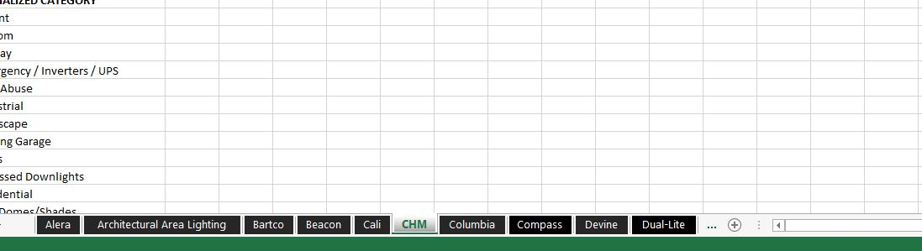

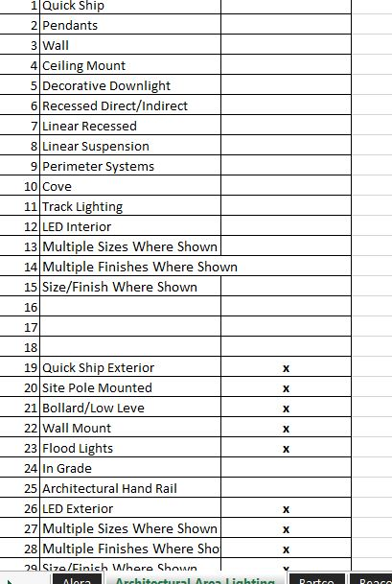

1. **Category ID List-**

Every category is assigned a category ID number that is associated to each product in the spreadsheet. When pulling products, the appropriate category ID number must be noted for the product. Products are divided by interior/exterior, LED interior/exterior, Quick Ship Interior/Exterior

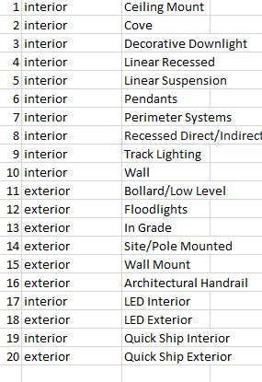

1. **Product Info Spreadsheet**

This is where all of the data will be collected. ***Columns that are shaded in blue do not require any entry.***

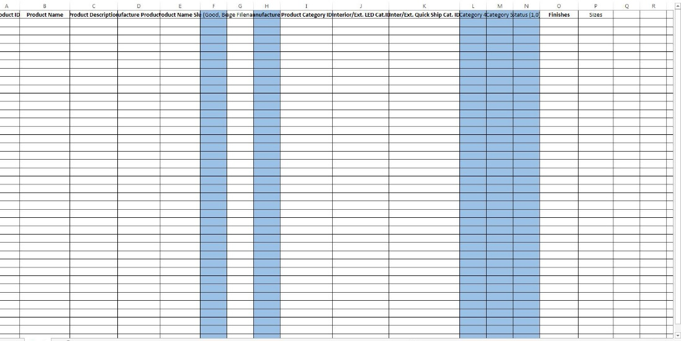

**Product Collection Process**

The information that is needed to be collected will require you to go to the manufacturer’s specific website. The URL for each manufacturer can be found within each tabbed page highlighted in yellow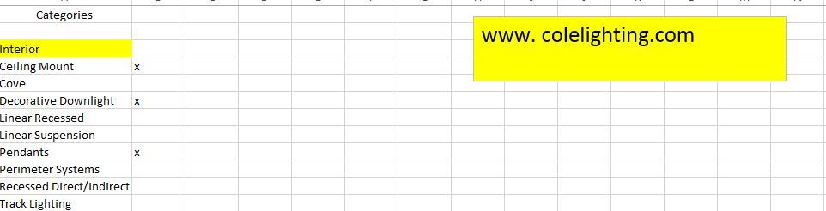

1. Begin by organizing the information you will need

* Manufacturer’s Worksheet
* Product Data Spreadsheet
* Category ID Spreadsheet
* Luminaire Selector Product Data Collection Guide
* A Folder set up on your desktop with the name of the manufacturer that you are working on.

1. Open the Manufacturer’s Worksheet and click on the first tab

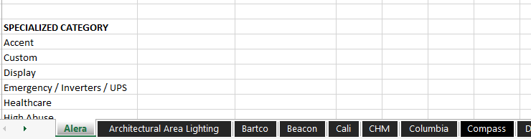

1. Start with the first category that is noted. In this example it is interior wall mount

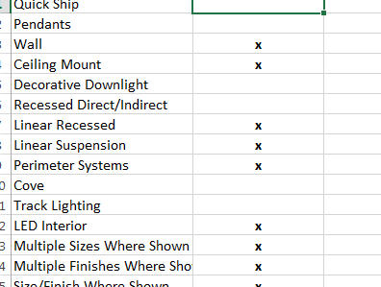

1. Click on the manufacturer URL-

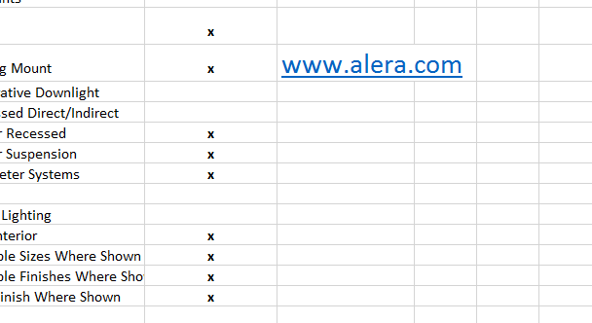

1. Once you have reached the website, find the “Products” category



1. Here you have two choices, Click on “all products” or in some cases there will be a selection that says “wall”

NOTE! In the lighting industry most of the manufacturers stay pretty consistent with their product descriptions. Sometimes though you will have to stop and study their products to make sure that you understand what the categories are in relation to the products. This may require you to do a little searching around the site.

In the case above, when you click on “products” in the menu you are not given the standard product listings ( wall, ceiling, pendant, recessed).

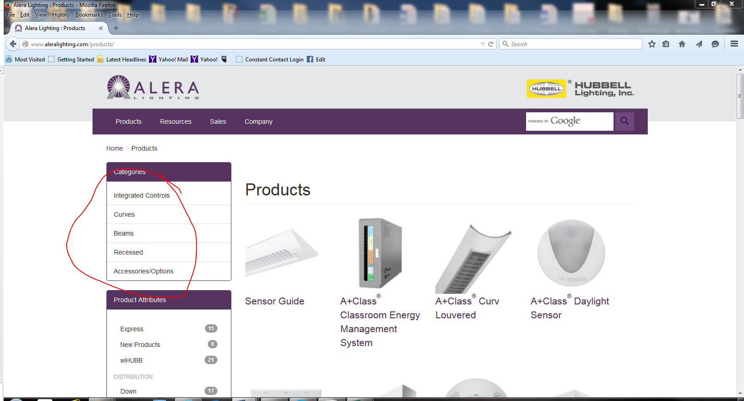

But by scrolling down you can find another area that will show you the available mounting types

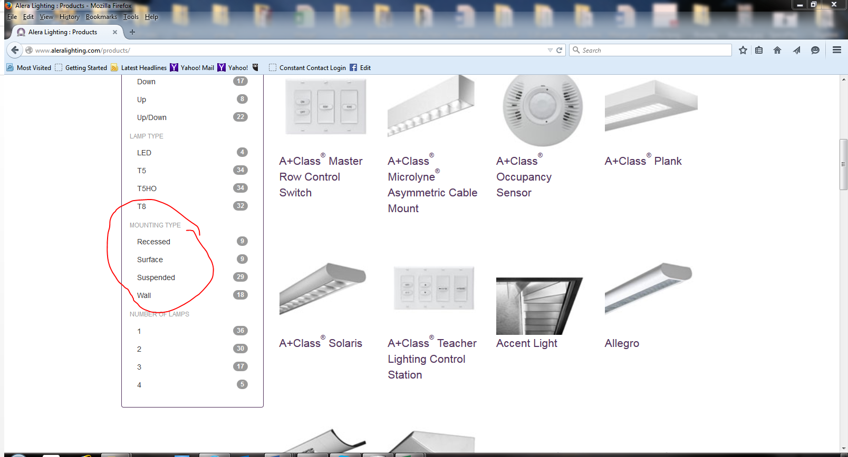

1. The first category you are working on is “wall”. Click on this to take you to those products

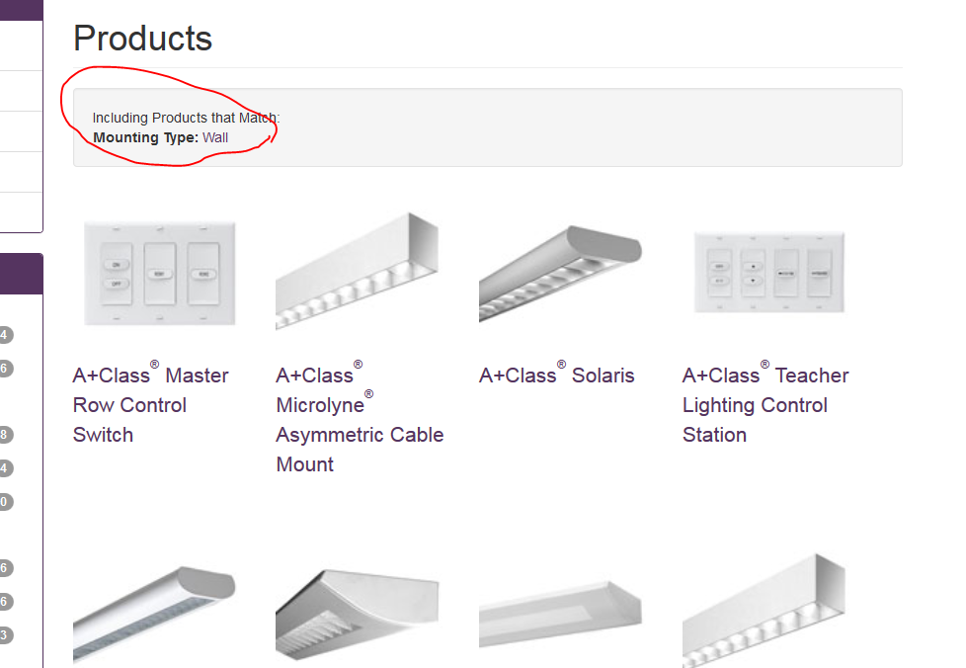

1. You are now ready to start the process of collecting data. Begin by clicking on the first fixture image. In this example it is Microlyne Asymmetric Cable mount

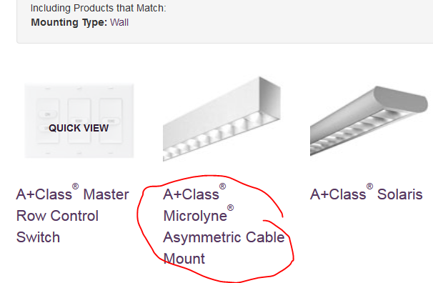

1. Once you have clicked on the image you will be taken to the “Cut Sheet” for that product. This is where all of the information is regarding this particular fixture. This is where you will collect all of your data.

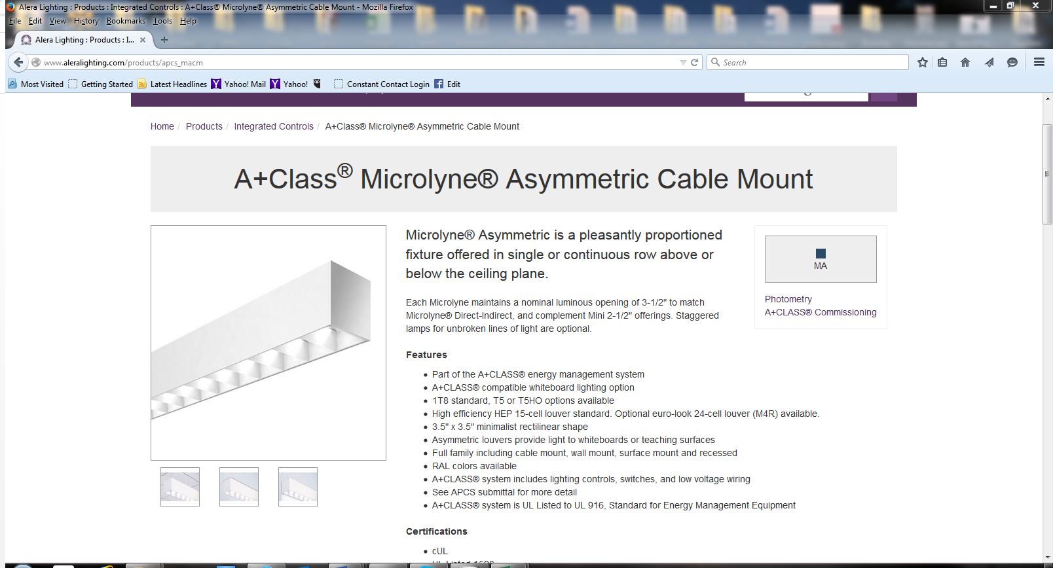

1. This is where you will begin using your Luminaire Selector Product Sheet

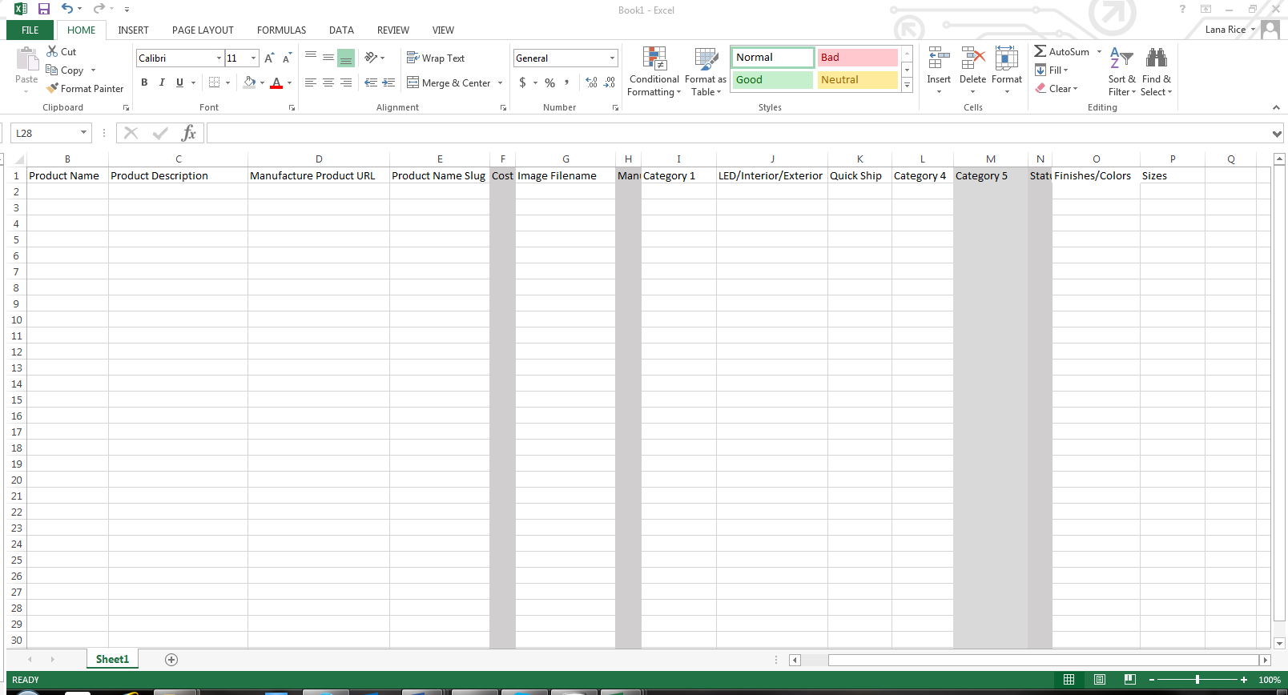

1. Begin with Column B – Product Name. Enter the product as it is named on the “cut sheet” page for this product

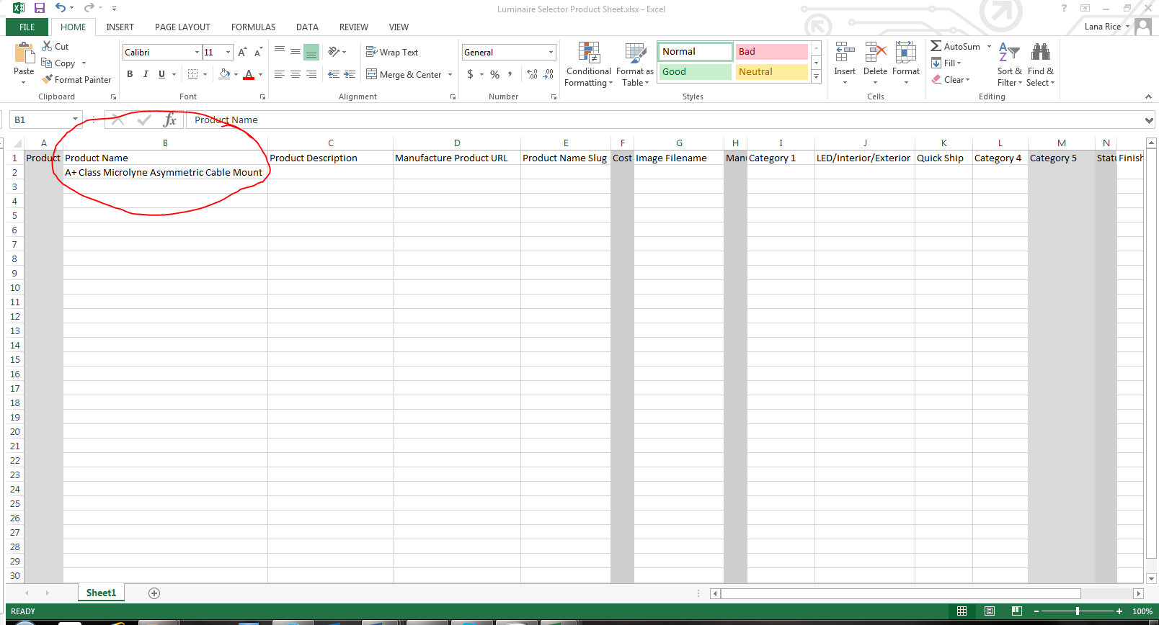

1. Move to column C- Product Description - Try to stay within 50 words or less for the description. NOTE: Most of the “Cut Sheets” will list several bullet points about the product. Pick out those that most describe the product. Think in terms of someone wanting to know “features & benefits”

For this product: the first two bullet points explain the product well enough that when they click on this product in the software program the will click further to learn more

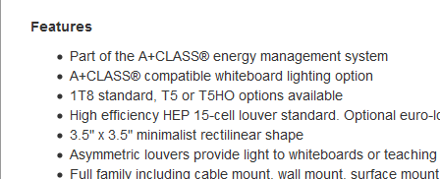

1. In most cases you can cut and paste the text into column C or Product Description

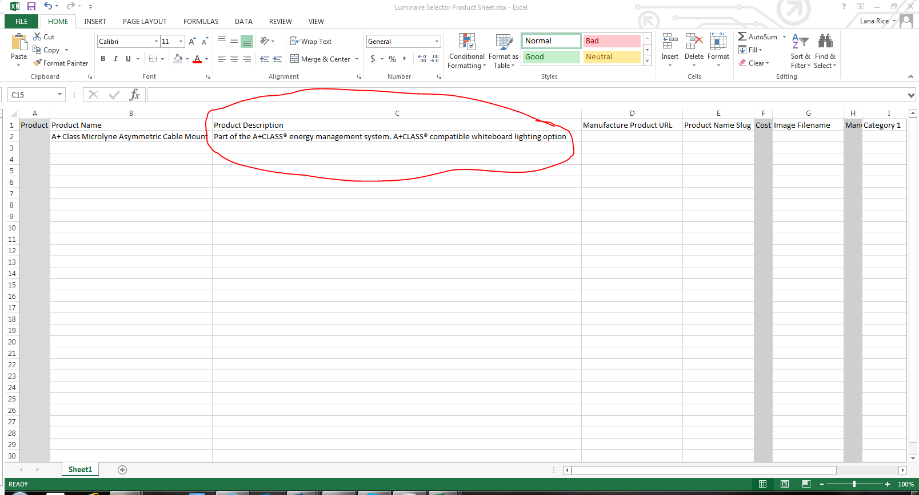

1. Next you will move to column D “Manufacture Product URL” Here you will want to go to the area where the URL is located for the “Cut Sheet “page

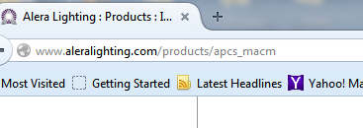

Copy and paste the URL into column D

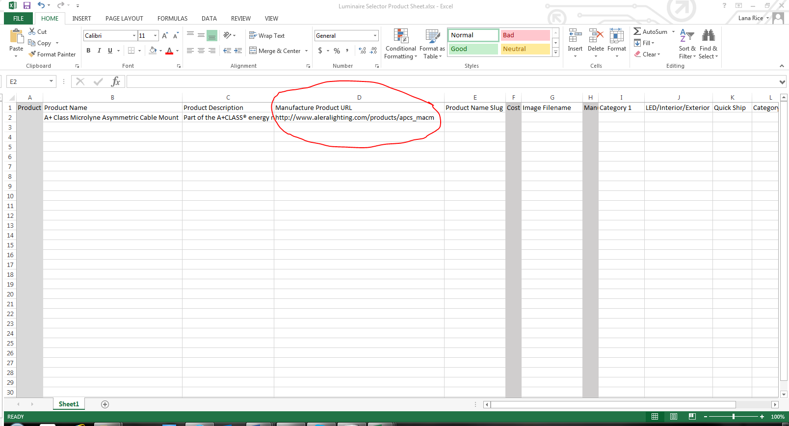

1. Then move to Column E- Product Name Slug- Here you will repeat the product name, but it must be in ALL LOWER CASE and each word separated by a dash (-)

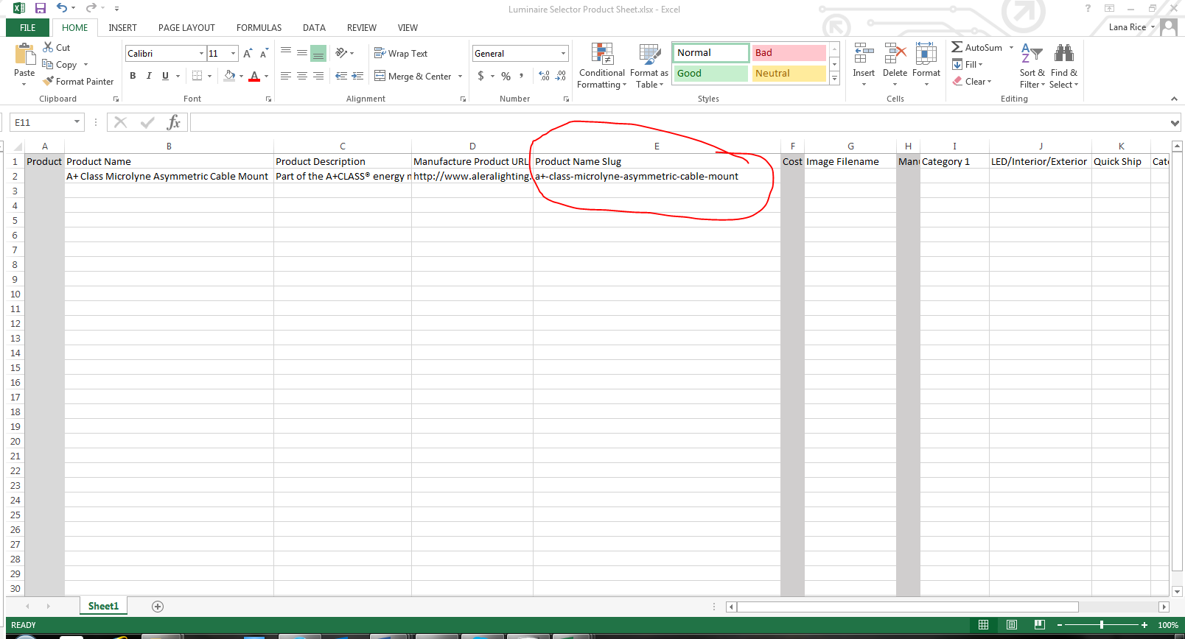

NOTE: DISREGARD ALL COLUMNS THAT ARE SHADED IN GRAY

1. Move on to Column G Image File Name. Important! You must choose the highest resolution photo available on the cut sheet. This may require you to click around to find the best image. In some cases it may require you to “clip” and image. No Thumbnails!

For this manufacturer, clicking on the largest image, produces a larger image. This is the one you will save

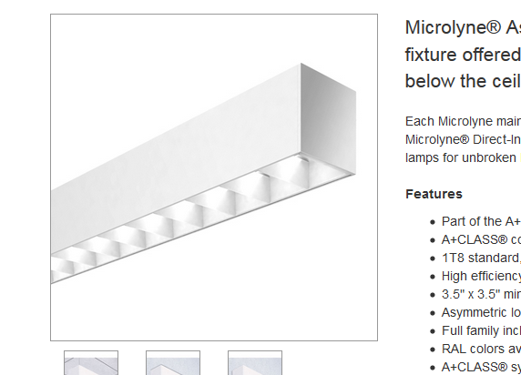 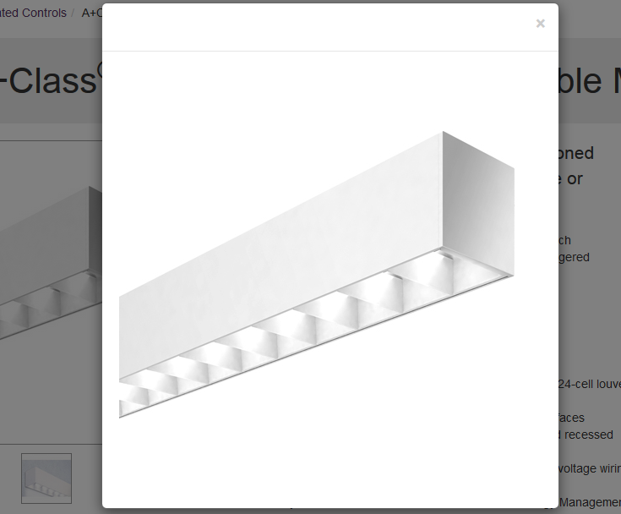

1. Right click on the image to reveal the pop box for “save as”

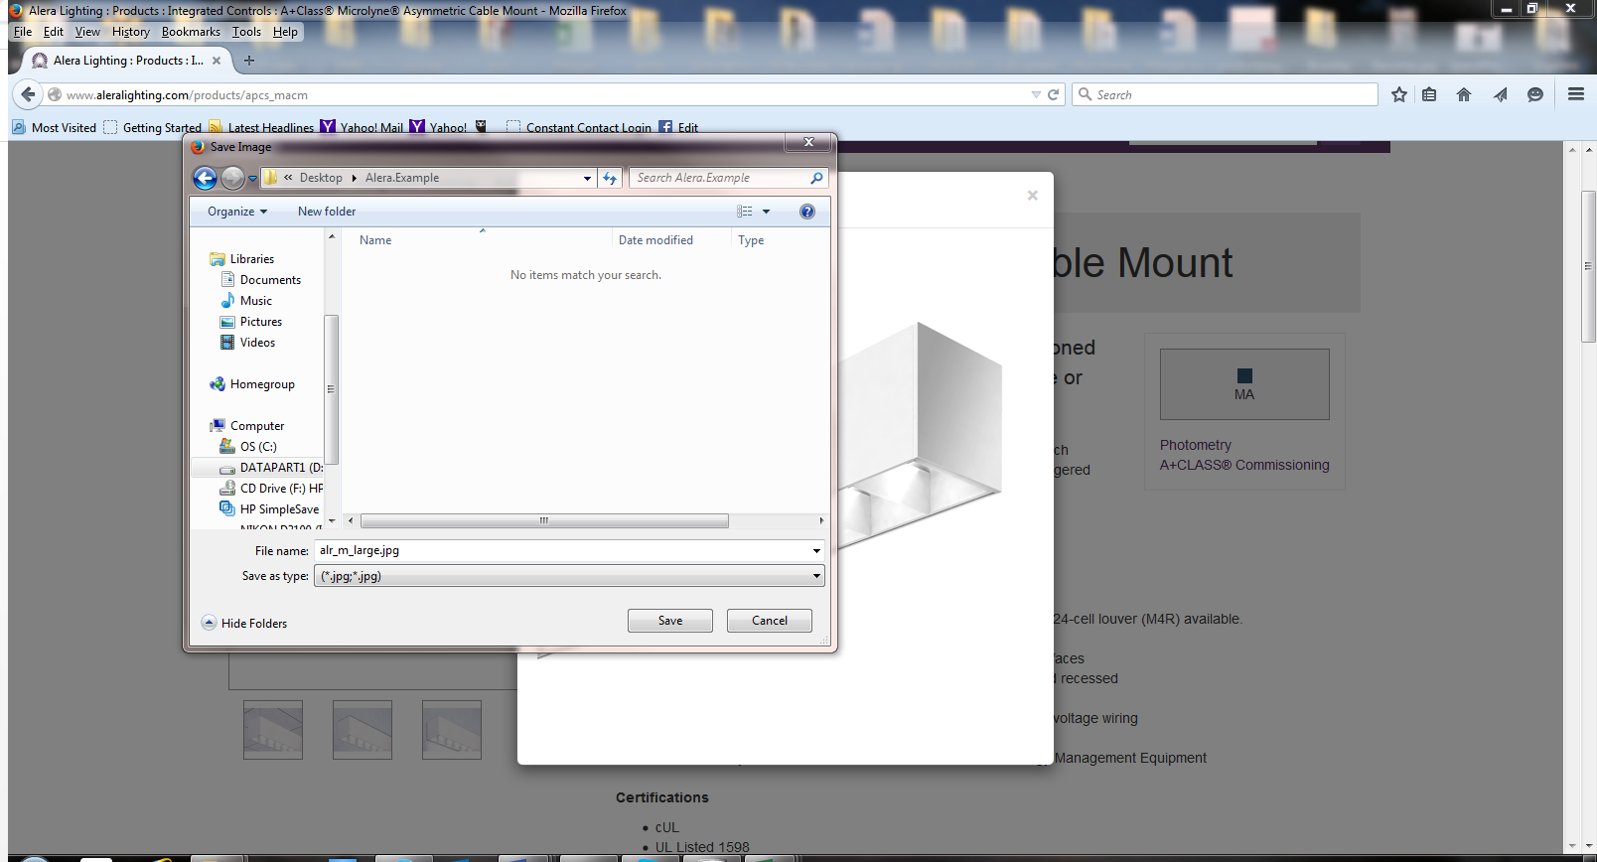

Before saving the image to your designated file folder COPY the image URL and put it in column G

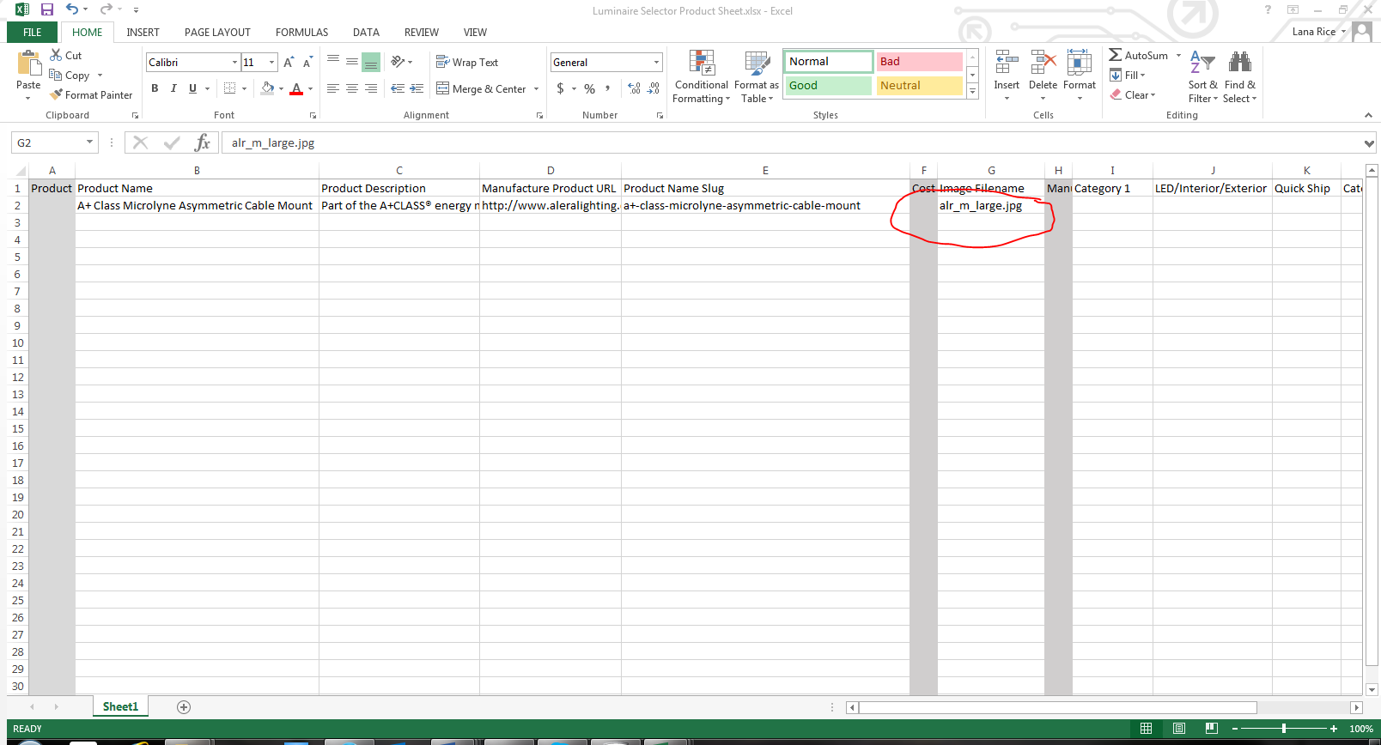

SPECIAL NOTE ABOUT IMAGES

* The image name that you save in the file MUST be EXACTLY the same as the image name that you put in Column G.
* If you always copy and paste the image name from before you save it you can make sure that the image name remains the same
* All images MUST HAVE a jpg. Extension in the spreadsheet- Sometimes the image that you save to the file will be a PNG image. Save the image to the file with the PNG extension. The images will be changed to a jpg later, but when you enter it into Column G, change the extension to jpg.
* All jpg extensions should be read as “.jpg” all lower case.

1. Next you will move to Column I – Product category. This is where you will need to refer to your Category ID Spreadsheet.

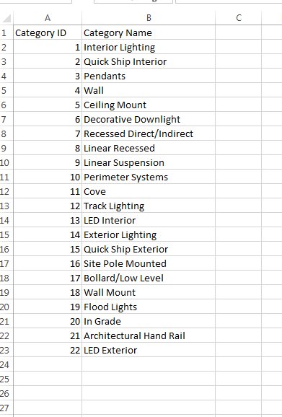

On you category sheet locate the ID code for “wall” In this case it is ID 4

Enter this in to Column I

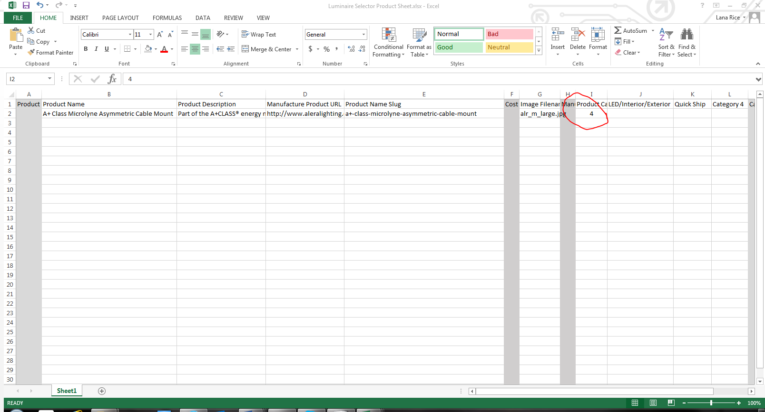

1. Column J is the LED category. There is an ID code for Interior and for Exterior. For this product you are working on Interior. This is where you will need to pay attention to the product information. This information can be found in a number of places, the description, certifications or in the specification sheet. Below are two examples of a product with and without LED

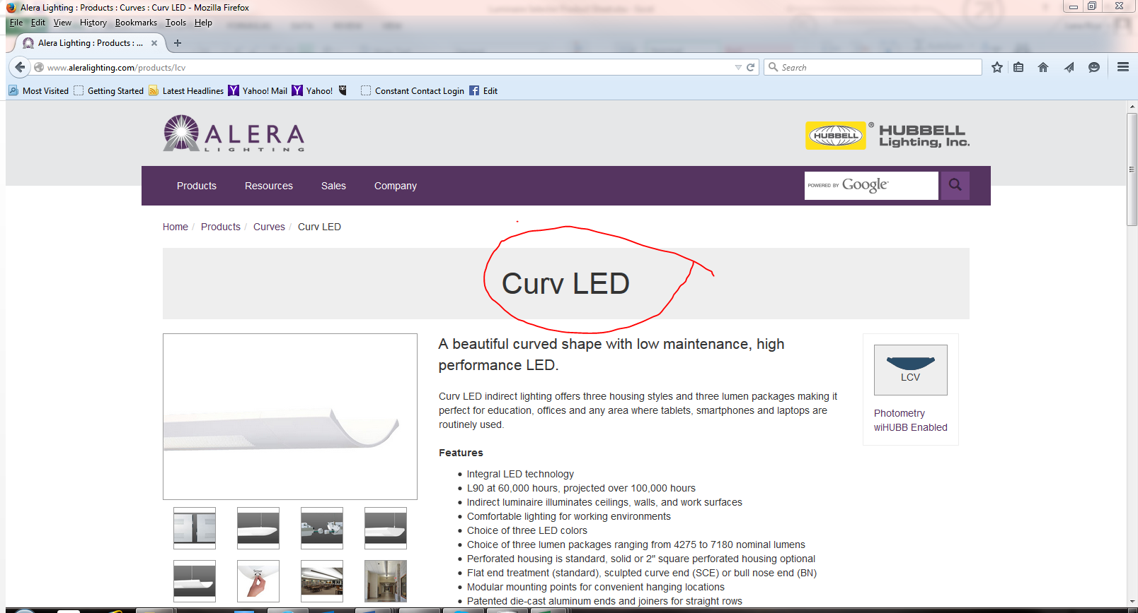

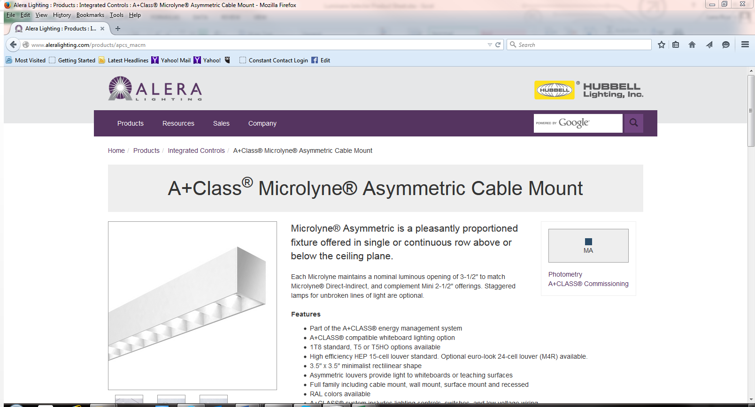

The Product that we are working on does not have LED but if it did, you would go to your category sheet and choose the appropriate ID#

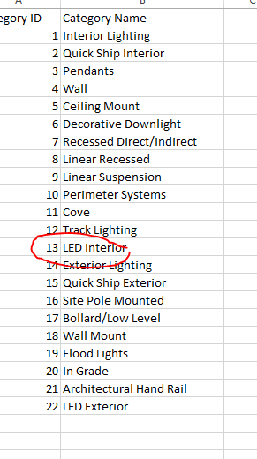

If it is an LED product - Remember! If you are working on Interior Fixtures you will use the ID code for Interior LED. If you are working on Exterior fixtures you will use the code for Exterior LED

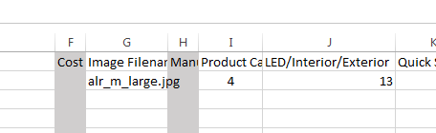

If not and LED product- Leave blank

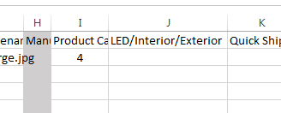

1. Next you will move to Column K- Quick Ship

If Quick Ship is available for the manufacturer, it will be noted on the manufacturer’s worksheet page. If it is noted that Quick ship products are available you can find them one of two ways.

* Click the drop down menu to fine “quick Ship”
* Do a search within the website to bring up quick ship items

NOTE: Just like LED REMEMBER there are Interior and Exterior Quick Ship

If the item you are working on is a quick ship item, enter the ID code in Column K, just as you did LED in Column I

With Quick Ship

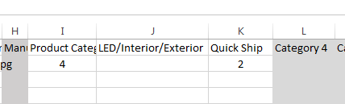

Without Quick ship

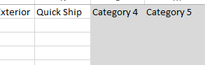

1. Next is Column O Finishes/Colors- This is very important to get correct

The best place to go for this information is the Specification Sheet. There will be one on every cut sheet. Sometimes you have to look for it but it is usually visual

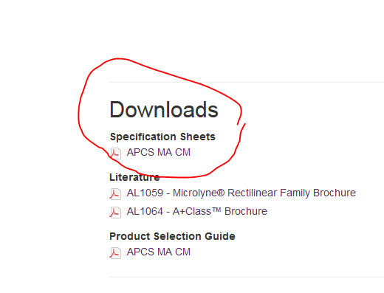

Open up the specification sheet and look for anything that says finishes or colors.

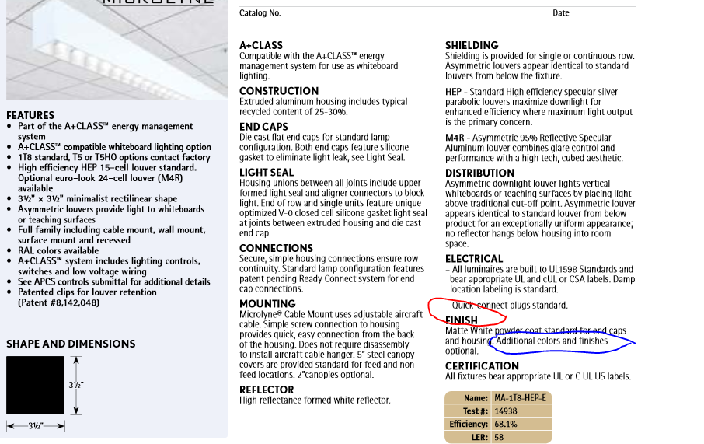

For this product it says “Matte White Power Coat” However, if you keep reading it says “additional colors and finishes optional

In Column O you would then put “Multiple Finishes/Colors Available”

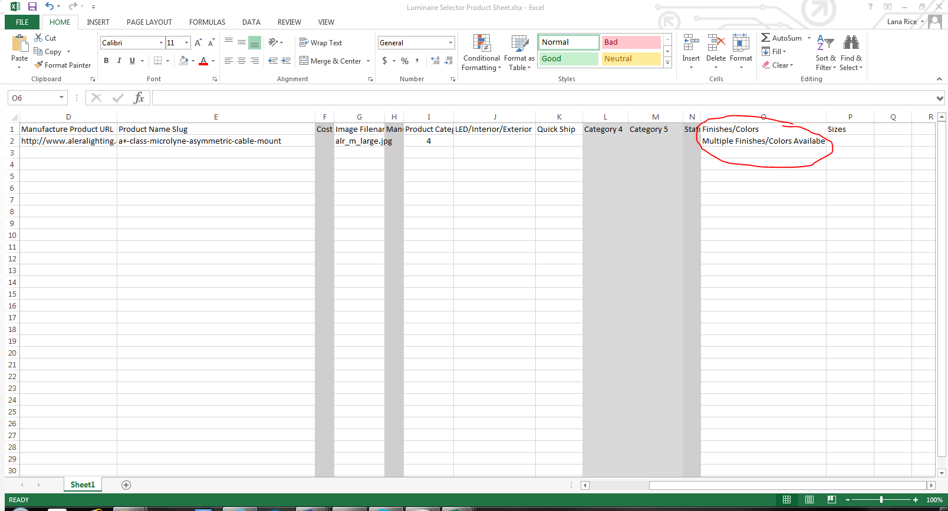

Here are scenarios for Column O

Multiple Finishes Available

Multiple Colors Available

Multiple Finishes/Colors Available

Or there could be a certain color

Example:

Red

Or a Finish

Example:

Bronze

The Specification Sheet will always give you the information on the finishes/colors

1. Finally you will move to Column P

This works much the same as Column O. Look for the information in the specification sheet

It is important to look carefully. For this product that we are working on

Notice these dimensions

It may seem that the Shape and Dimensions reference is the size available ( circled in red) but if you look further down (circled in blue) that there are multiple sizes

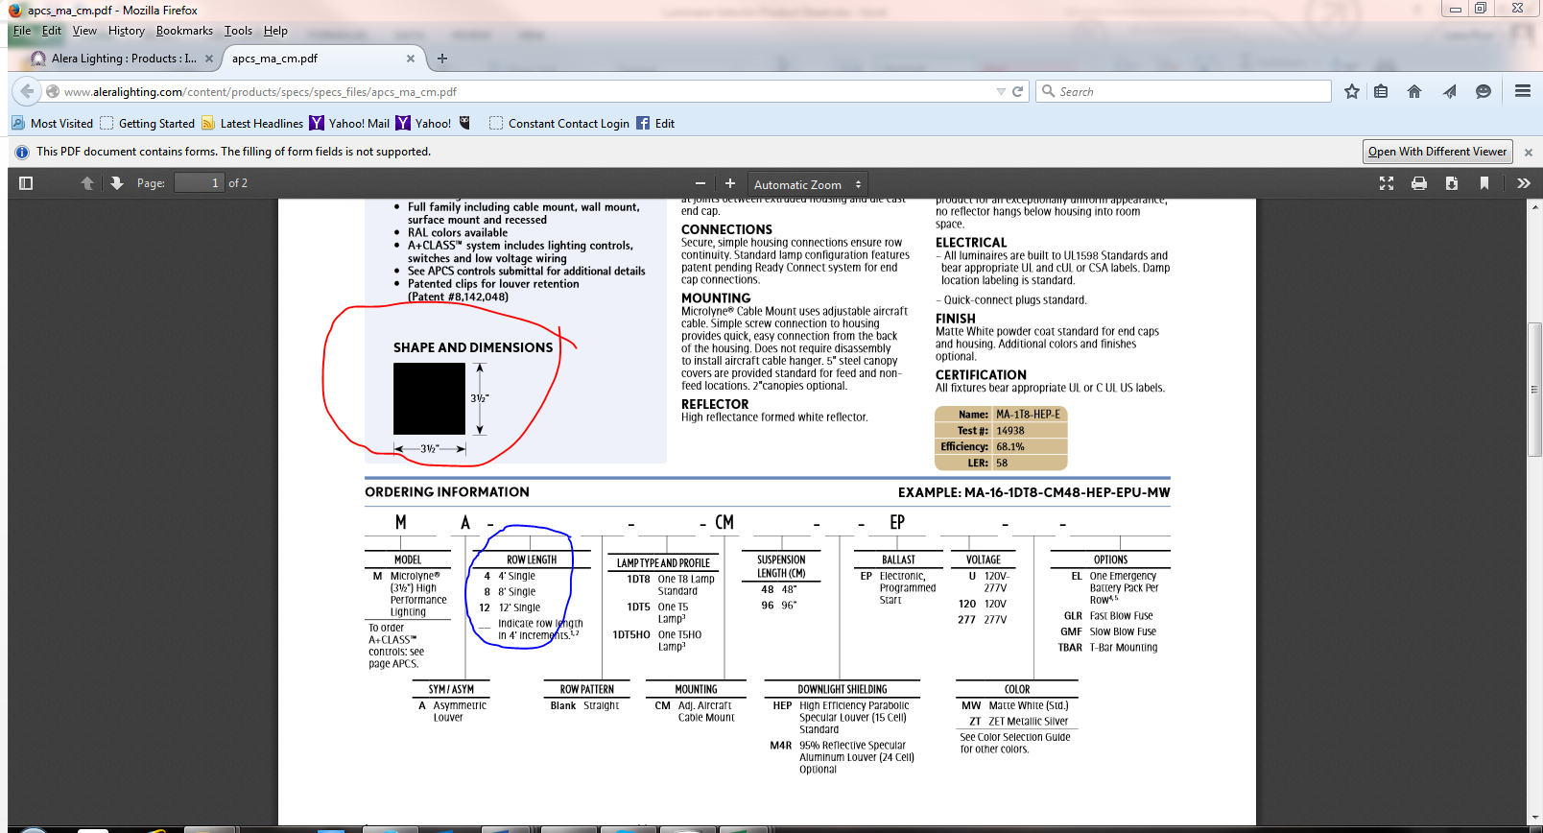

In this case you would enter in Column O - Multiple Sizes

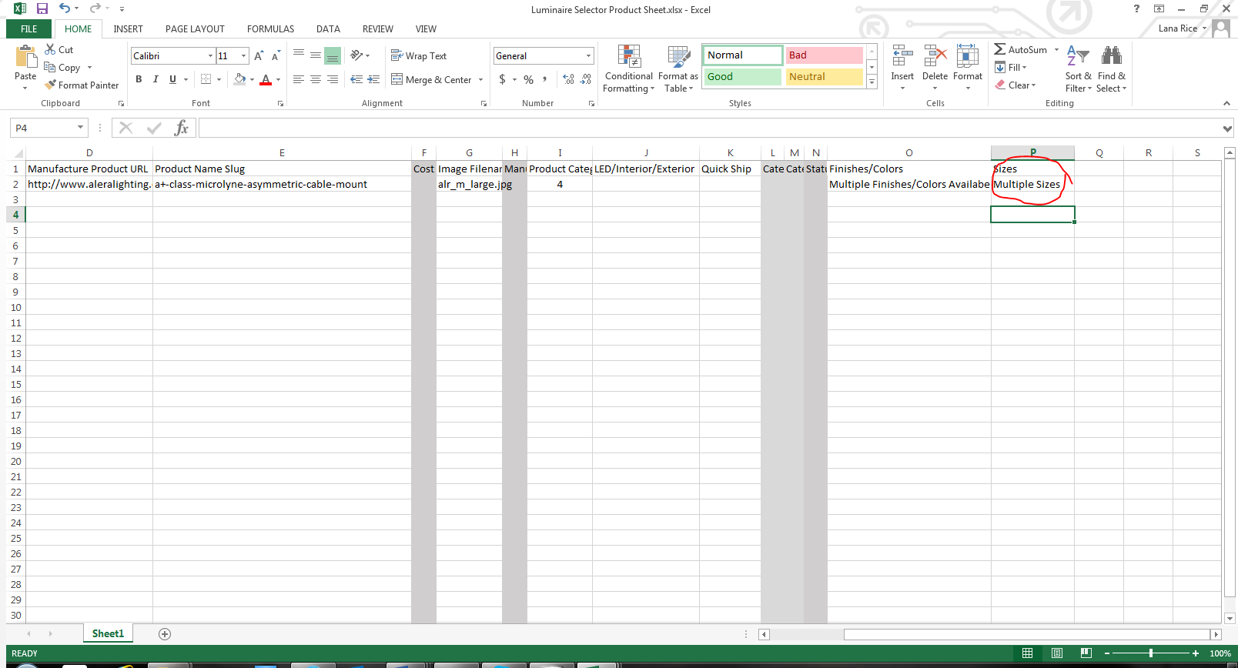

This is an example of a specification sheet that has one size

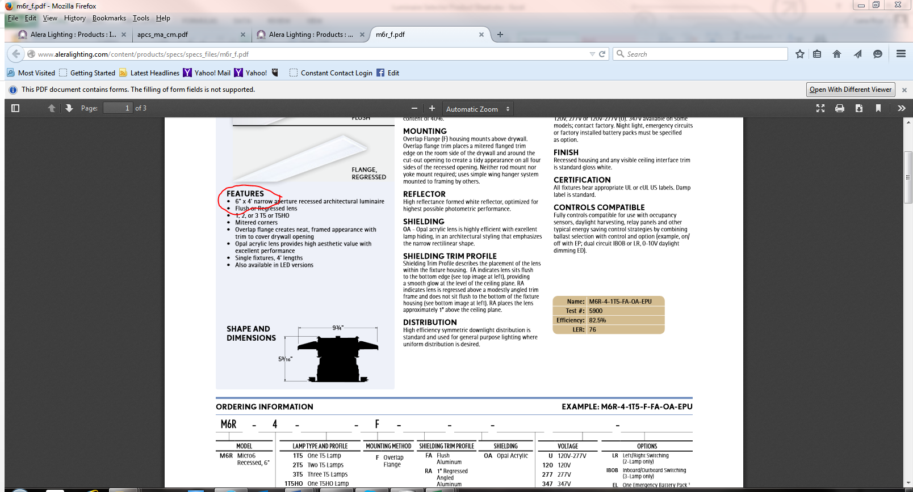

And this is how that information looks in the spreadsheet

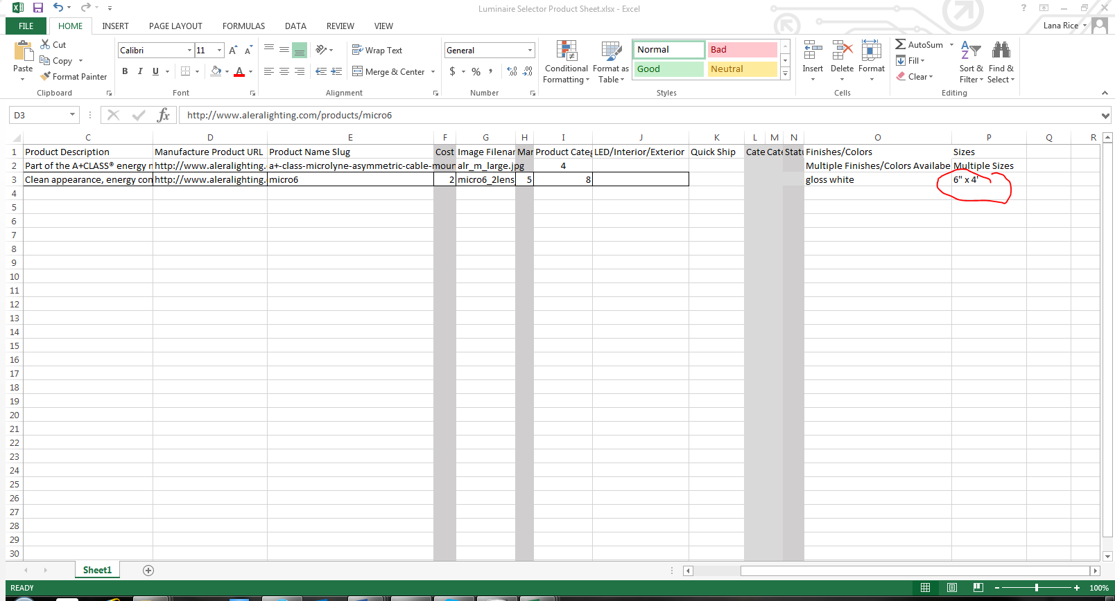

The key is to look carefully to make sure that you are pulling the CORRECT information

Once you have pulled all of the first category, proceed until you pull all of the categories noted for that manufacturer

Once the information is pulled for that particular manufacturer, put the a copy of the spreadsheet in the file folder, zip it up and upload it to

<https://www.hightail.com/u/TargetSourceFiles>

Then proceed to the next manufacturer on your list.

ACCURACY IS KEY… A BONUS WILL BE PAID FOR ACCURACY.